


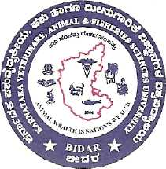
INSTITUTE OF ANIMAL HEALTH AND VETERINARY BIOLOGICALS

SOUTHERN REGIONAL DISEASE DIAGNOSTIC LABORATORY

DIAGNOSTIC BIOCHEMISTRY & TOXICOLOGY

HEBBAL, BANGALORE – 560 024

No: IAH/SRDDL/BIO-TOX/ /2017 -18 |  | Date: 18/05/2017
DIO NO: IAH/SRDDL/ /2017-18 |  | REF. NO:
ANIMAL: --- |  | SPECIMEN: Feed
OWNER NAME & PLACE
REFERRED BY
SUBJECTED FOR | Feed Analysis

LABORATORY RESULTS

Mycotoxin Analysis

Parameters | Maximum Permissible Limit | Feed pellet
Aflatoxin B1 | 20 ppb | 1.75ppb

Proximate Parameters
Parameter | Feed Pellet
Moisture | 7.86 %
Dry matter | 92.14 %
Total Ash | 13.01 %
Crude Protein | 10.33 %

Inference:
In the given feed sample, Aflatoxin B1 level was found to be within maximum permissible limit.

SCIENTIST JOINT DIRECTOR

